

Foundations of Programming

Assignment No.: 18
PROBLEM STATEMENT: Write a C program that accepts a string from the user and performs the following string operations: i) Calculate length of string ii) String reversal iii) Equality check of two strings iv) Check palindrome v) Check substring.

OBJECTIVE:

- To understand basic string operations in C.
- To learn how to manipulate strings using loops and functions.
- To perform comparison, reversal, and substring checking.
- To check whether a string is a palindrome.

THEORY:
In C programming, a string is a sequence of characters terminated by a null character ('\0'). Strings are commonly stored in character arrays. Various operations can be performed on strings such as calculating their length, reversing the characters, comparing two strings, checking whether a string is a palindrome, and finding a substring within another string. These operations can be implemented using loops and conditional statements or by using standard library functions from the string.h header file.
PLATFORM: Linux
CODE:
#include <stdio.h>
#include <string.h>

int main() {
char s1[100], s2[100], rev[100];
int i, j, len, isPalindrome = 1;

printf("Enter a string: ");
scanf("%s", s1);

len = strlen(s1);
printf("Length: %d\n", len);

for (i = len - 1, j = 0; i >= 0; i--, j++) {
rev[j] = s1[i];
}
rev[j] = '\0';
printf("Reversed: %s\n", rev);

printf("Enter another string for equality check: ");
scanf("%s", s2);
if (strcmp(s1, s2) == 0) printf("Strings are Equal\n");
else printf("Strings are Not Equal\n");

for (i = 0; i < len / 2; i++) {
if (s1[i] != s1[len - 1 - i]) {
isPalindrome = 0;
break;
}
}
printf("Palindrome: %s\n", isPalindrome ? "Yes" : "No");

printf("Enter substring to find: ");
scanf("%s", s2);
if (strstr(s1, s2) != NULL) printf("Substring found!\n");
else printf("Substring not found.\n");

return 0;
}

INPUT: A string and another string for comparison and substring checking.

OUTPUT: Displays string length, reversed string, equality result, palindrome result, and substring check result.

SAMPLE INPUT:

Enter a string: madam
Enter another string for equality check: mad

SAMPLE OUTPUT:
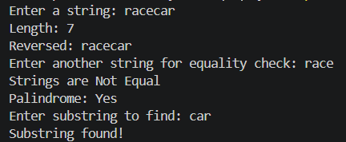
CONCLUSION: Thus, the C program successfully performs different string operations such as length calculation, reversal, equality check, palindrome check, and substring detection.

FAQs:
- What is a string in C programming?
- Which header file is required for string functions?
- What function is used to find the length of a string?
- What is a palindrome string?
- Which function is used to check a substring in C?

